**Below are steps to run this project.**

1. Copy TaskManager.war into tomcat\webapps directory
2. Extract capsule-project project and go to command line with directory path
3. Enter below command

Npm install

1. Enter below command

Ng serve

1. In brower enter below url

<http://localhost:4200>

1. capsule-project component will start compiling, if it gives compilation error on index.d.ts then apply below fix
   1. Copy contents from node_modules/@types/bootstrap/index.d.ts.fix to [node_modules/@types/bootstrap/index.d.ts](mailto:node_modules/@types/bootstrap/index.d.ts)
   2. It will compile now successfully
2. UI application will be displayed in browser

**Project Screenshots:**

1. Add New User screen-

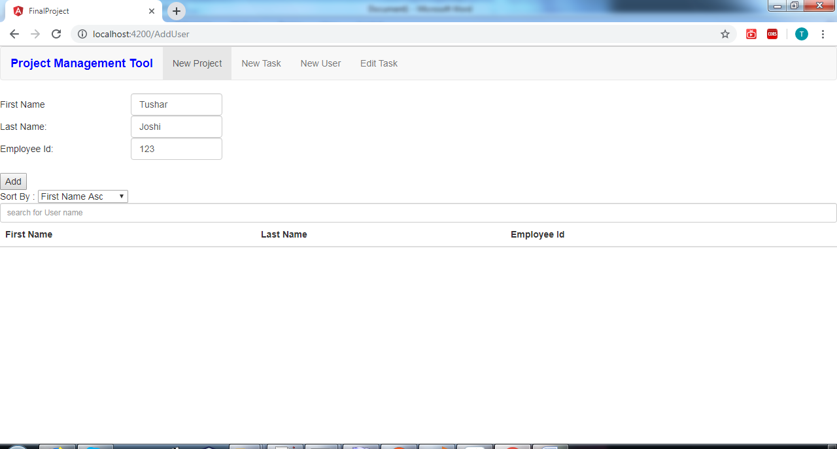

1. After clicking on Add button, user got saved into database and shown in below table

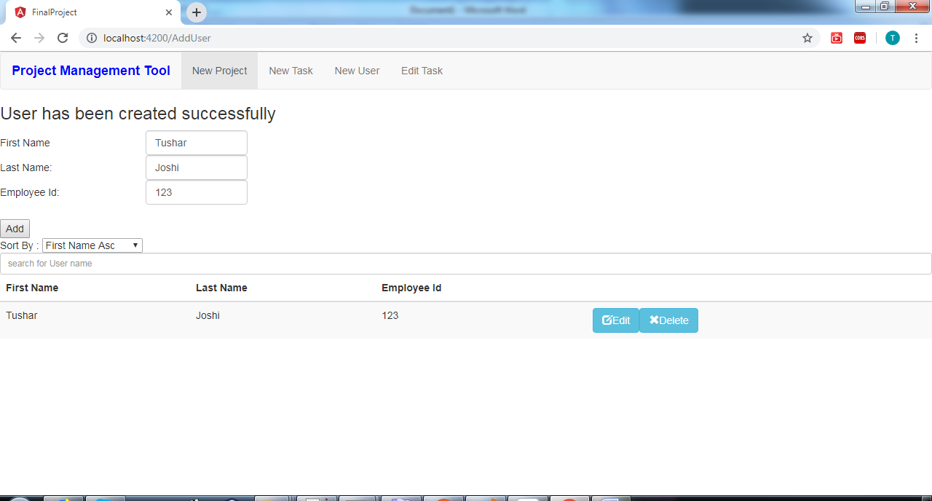

1. One more user added

e 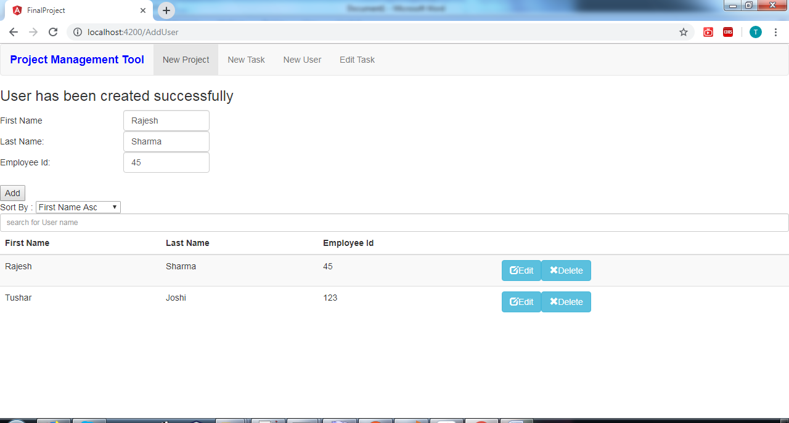

1. Edit User and change emp id

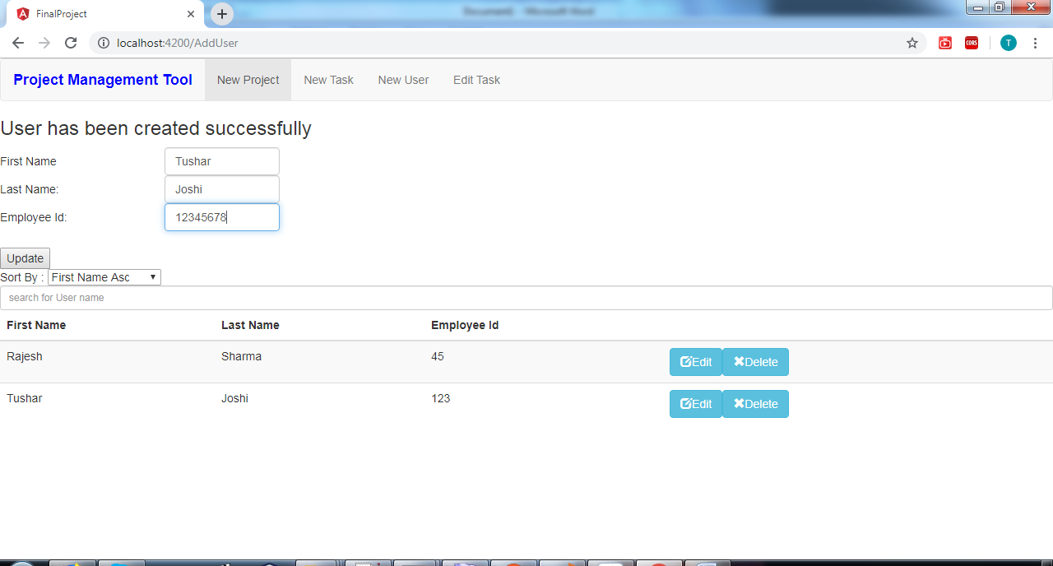

5.After clicking on update button, changes to existing user got saved.

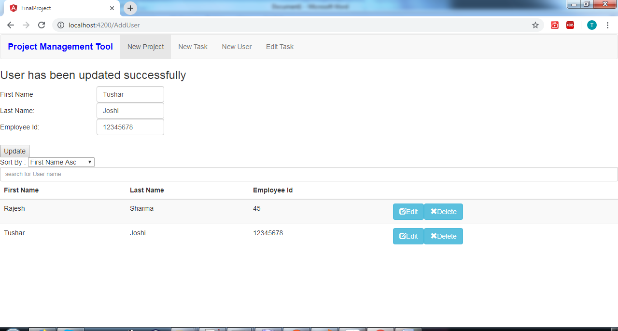

6.Click on New Project menu

7. Click on Add button directly, it will show error messages about mandatory fields

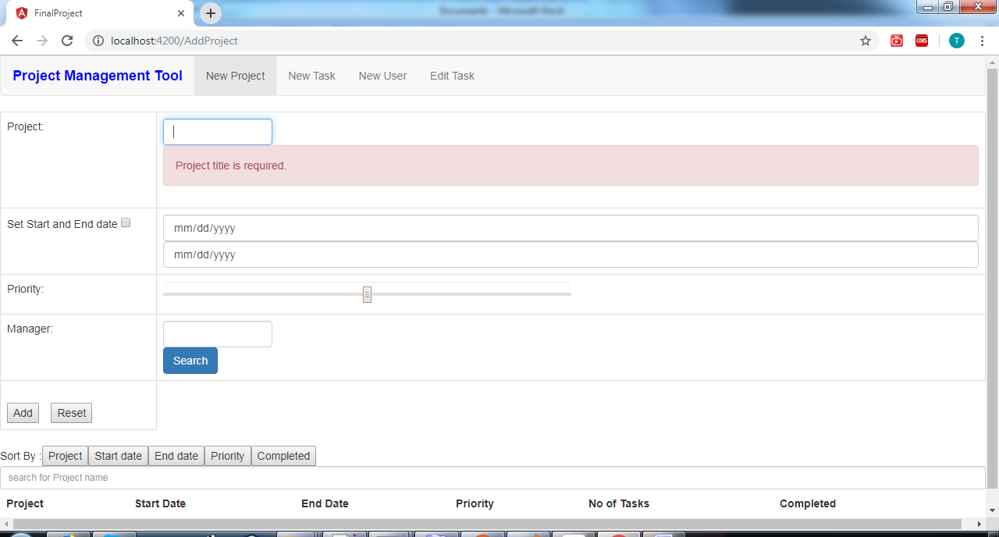

8.Fill details of new project and click to select manager from Users

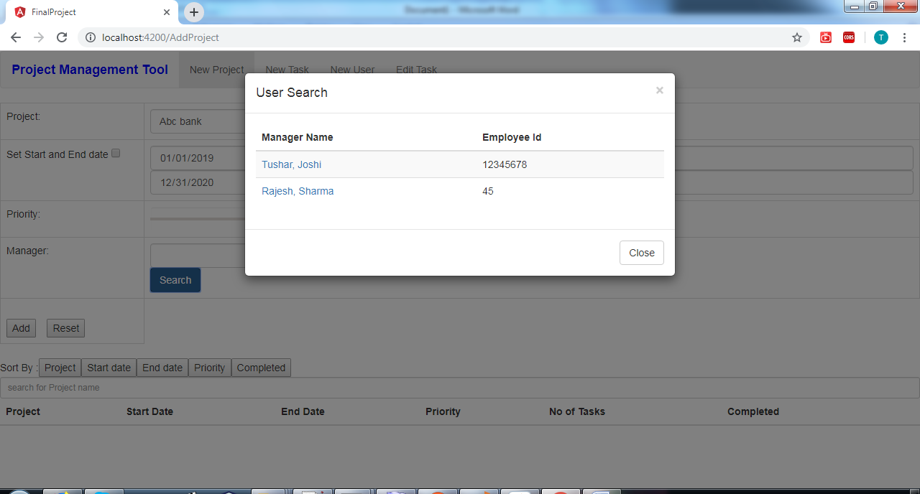

9.Click on Add button to save new project in below table

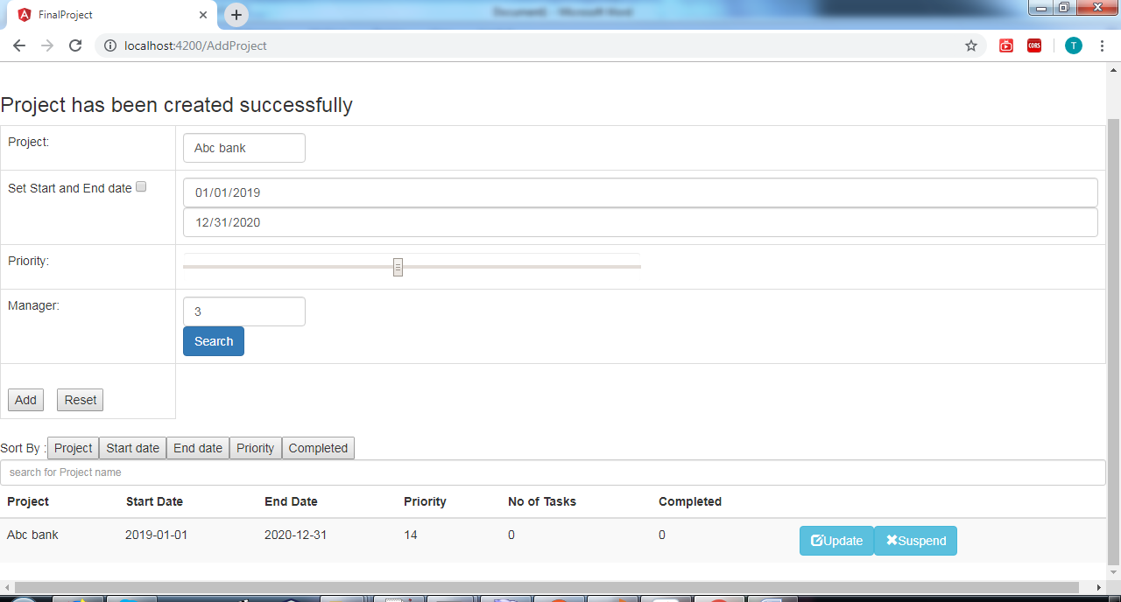

10. Click on New task menu

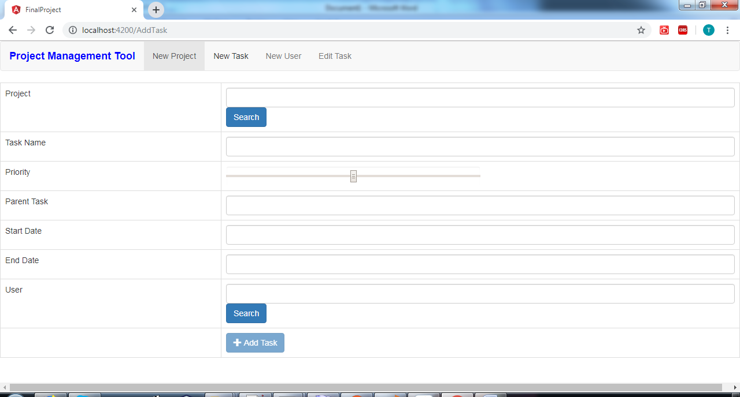

11.Select existing project to add task in that project

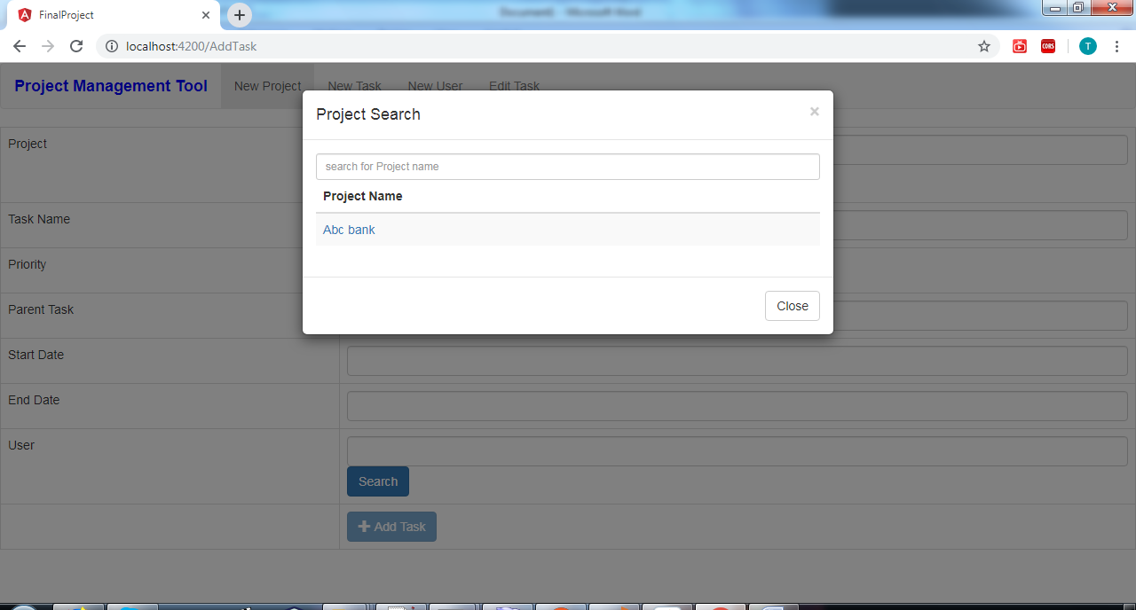

12.Add user to task by selecting it

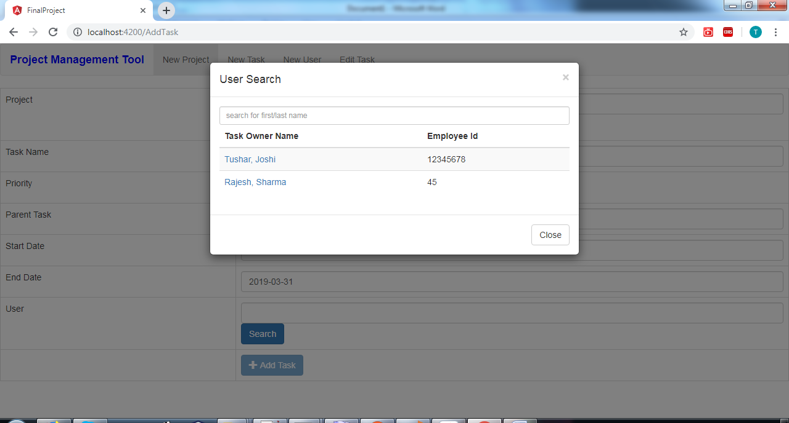

13.After clicking on Add task button, new task will get created

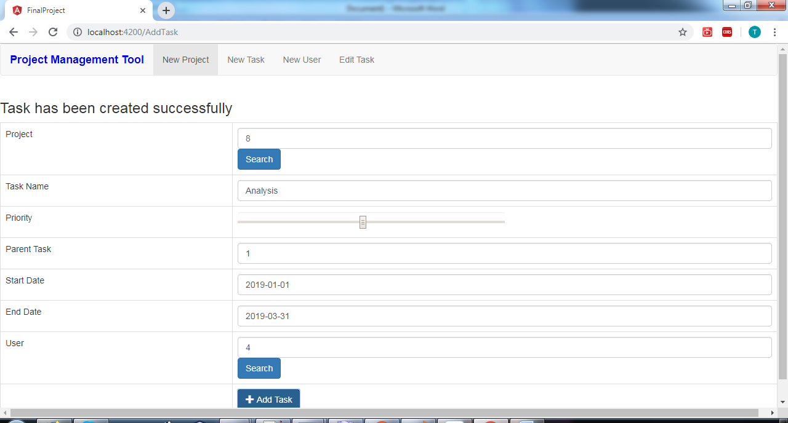

14. Click on Edit Task menu and select existing project

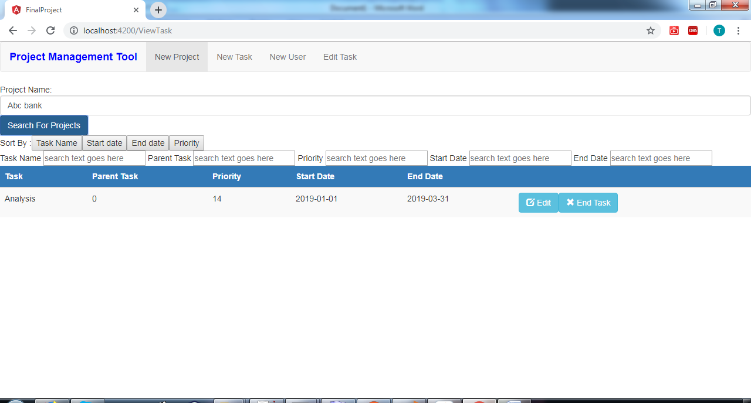

15. Click on Edit button to modify task

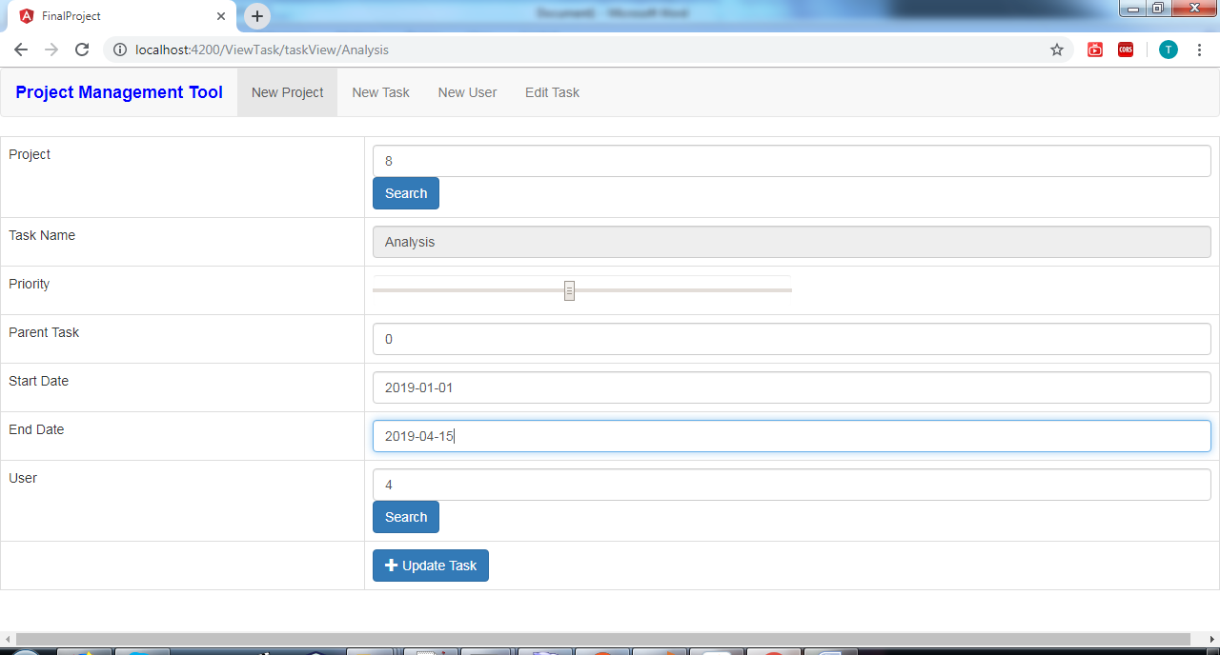

16. Click on Update task button to update it

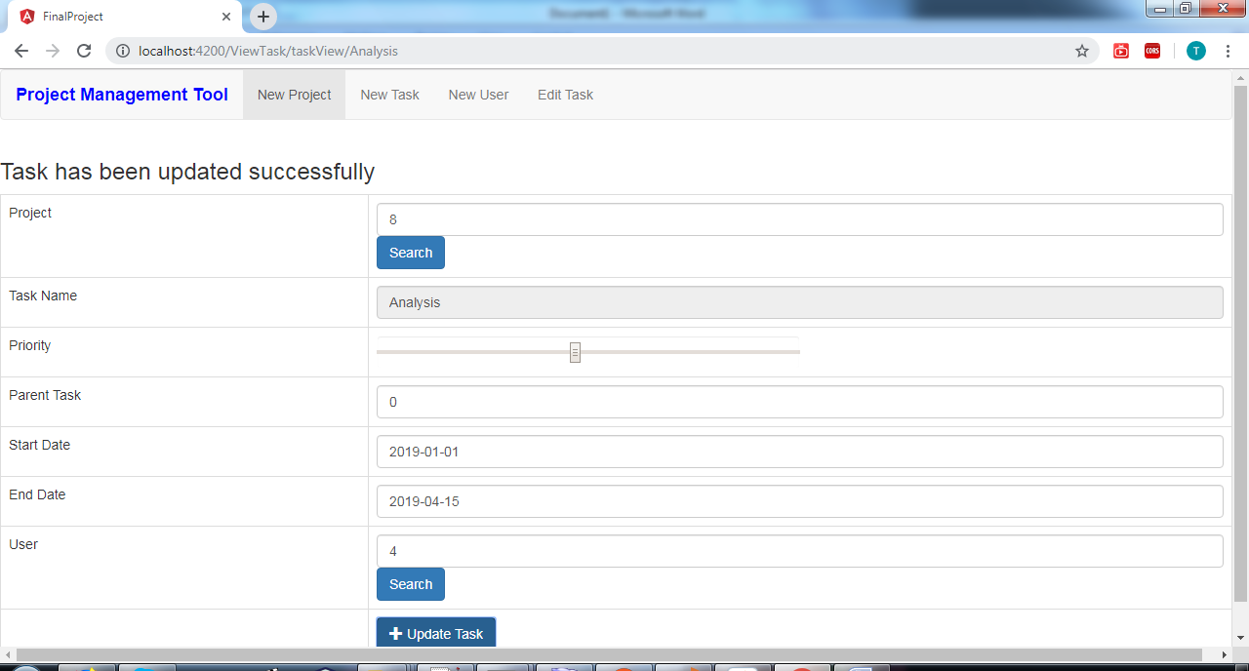

17. Click on New Project menu. Check Task no got changed to 1 as new task added into project ‘Abc bank’

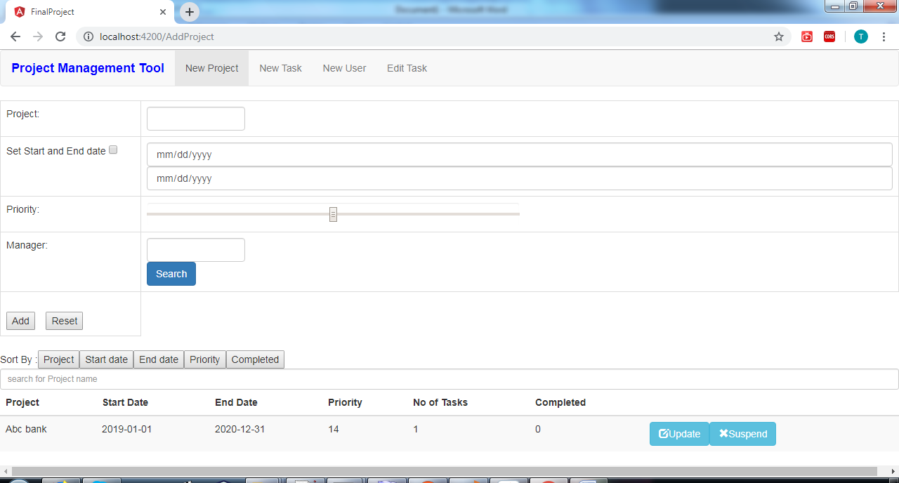

18. Added one more project

